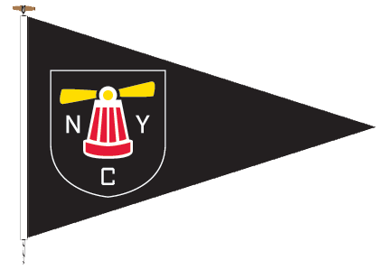 | CLUB RACING  ENTRY FORM  2023  Statement of Yacht & Competitor info  Declaration of insurance cover | 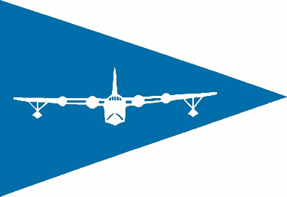
Neyland Yacht Club Pembroke Haven Yacht Club

EVENT (State universal all-season entry or individual Race, or Series)
BOAT NAME
BOAT TYPE
Byron James NUMBER (base/no spinnaker)
SAIL NUMBER
HULL COLOUR
NAME
ADDRESS
CLUB
PHONE NUMBER /MOBILE NUMBER
EMAIL

INSURANCE & LIABILITY
I confirm that this boat is insured for racing against a third party liability of at least £3 million.
I understand that it is the competitor’s sole responsibility whether or not to start, or to continue in, any race.
The Clubs and Neyland Yacht Haven accept no responsibility or liability for loss of life or injury to members, or others, or for the loss of or damage to, any vessel.

If your boat details have changed or you are new to either Club, or you intend to sail Gentleman’s division or outside agreed divisional split, please inform the Race Officer.

SIGNED (Owner/Entrant)…………………………………………

DATE : …………………………..
Please submit this form to Club Racing officer/Race Deck.
NYC - yachts@neylandyachtclub.co.uk PHYC – 1@chrisandalan.com
__________________________________________________________________________
FOR COMMITTEE USE ONLY
ENTRANCE FEE PAID (If applicable) | nnnnnnnnnnnnnnnnnnnnnnnnnnn
ENTERED INTO SAILWAVE
VALID BJ NUMBER
PROOF OF CORRECT INSURANCE COVER

