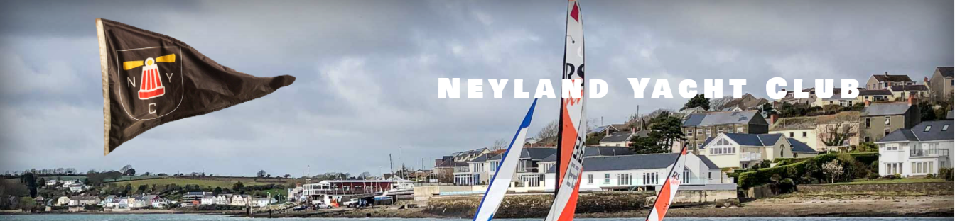

Notice of Race
Neyland Yacht Club Cruiser Summer Regatta
26th to 27th August 2023

1. Organising Authority. Neyland Yacht Club.
2. Rules. Racing will be governed by the World Sailing Racing Rules of Sailing (RRS) 2021-2024, the prescriptions of the RYA, and class rules where appropriate except where changed by the sailing instructions.
3. Eligibility. This series is open to all sailors who hold membership of an RYA affiliated sailing or yacht club. All boats will require a 2023 Bryon James rating. Under agreement from the Club Yacht Captain, a class BJ rating may be used by members of other clubs taking part in the regatta.
4. Classes. The Bryon James rating system will be used. The rating for a boat will need to be verified by the Club Yacht Captain and may be subject to independent verification.
Fast Division 1 – Pennant 1 – All yachts below BJ 1000.
Slow Division 2 – Pennant 2 – All yacht BJ 1000 and above.
Variations: Boats close to BJ1000 can opt to race in either fleet subject to agreement of the Race Officer.
To make a division valid, there must be at least three yachts entered. However, only two need to be present to constitute a race.
5. Location. The series will be run from Neyland Yacht Club using a combination of fixed channel marks and club marks for the course(s).
6. Entries. Entry fee to cover races in the series will be as follows:
Saturday 26th August only – £10
Sunday 27th August only – £10

7. Registration. All helms must register their boat to race. A registration form can be downloaded at www.neylandyachtclub.co.uk/ and should be submitted to yachts@neylandyachtclub.co.uk by Thursday 24th August. Paper copies will be available in the Starter’s Cabin on Wednesday 23rd August.
8. Races The series will consist of 4 races. 2 races per day, with each race starting directly after the previous race. First warning signal will be 1100 The target time for each race will be 90 minutes There will not be a discard for this series. This changes RRS A2.1.
9. Briefing. Before the first race each day, there will be a briefing over VHF channel 37 to explain the course and outline any applicable safety information.
10. Safety.
- The safety of a yacht and her entire management including insurance is the sole responsibility of the owner/competitor racing the yacht who must ensure that adequate safety equipment is carried.
- The decision on whether or not to start or continue in a race is that of the owner/competitor; the race organisers accept no liability for loss, injury or damage. The race officer has the authority on duty-of-care grounds to cancel, postpone or delay any planned race at any time.
- Moreover, every owner/competitor warrants the suitability of his yacht for the races.
- All yachts shall carry:
  - A minimum third-party insurance in the sum of £3,000,000.
  - An engine capable of propelling the yacht at 4 knots in calm water and sufficient fuel for 2 hours of motoring. The engine and associated equipment must be fully functioning and in a safe working order before the starting procedure commences. Random checks may be carried out by the Race Committee.
  - A VHG radio capable of transmitting and receiving Channels 16, 12 and 37. MHPA signal station wishing to communicate directly with a yacht will call on Channel 16 and request yacht(s) to switch to Channel 12. On completion of any such communication the yacht(s) concerned will resume dual watch on Channel 16 and Channel 37. The Club strongly advise all yachts to monitor commercial activity on Channel 12, especially when tankers are being berthed or when the Ferry is en route. Random radio checks may be carried out at the discretion of the Race Officer.

