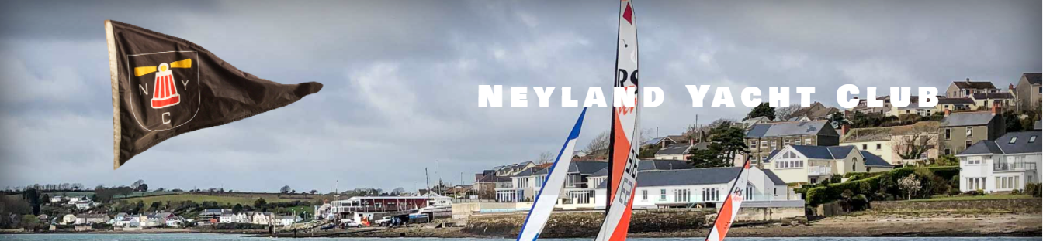

Notice of Race
Neyland Yacht Club Dinghy May Regatta
11th to 12th May 2024

1. Organising Authority. Neyland Yacht Club.
2. Rules. Racing will be governed by the World Sailing Racing Rules of Sailing (RRS) 2021-2024, the prescriptions of the RYA, and class rules where appropriate except where changed by the sailing instructions.
3. Eligibility. This series is open to all sailors who hold membership of an RYA affiliated sailing or yacht club. There are no restrictions on what boats can be used.
4. Classes. The Portsmouth Yardstick rating system will be used.
Fast Division 1 – Pennant 1 – All dinghies below PY 1100.
Slow Division 2 – Pennant 2 – All dinghies PY 1101 and above.
Variations: Boats close to PY 1100 can opt to race in either fleet subject to agreement of the Race Officer.
To make a division valid, there must be at least three dinghies entered. However, only two need to be present to constitute a race.
5. Location. The series will be run from Neyland Yacht Club using a combination of fixed channel marks and club marks for the course(s).
6. Entries. Entry fee to cover races in the series will be as follows:
Saturday | Sunday
Single hander - £20 | Single hander - £10
Double hander - £25 | Double hander - £15

7. Registration. All sailors must register to race. Complete the entry form: https://forms.gle/fdsZt7ZrDHZJyBab8 by Tuesday 7th May 2024.
8. Races The series will consist of 8 races. 6 course races on Saturday. 2 long distance races on Sunday. First warning signal will be 1055. The target time for each race on Saturday will be 30 minutes, with a time limit of 45 minutes. The target time for each race on Sunday will be 90 minutes. There will be 1 discard for this series.
9. Briefing. Before the first race each day, there will be a briefing at the Starter’s Cabin to explain the course and outline any applicable safety information.
10. Safety.
- The safety of the boat is the sole responsibility of the owner/competitor. This includes having adequate insurance.
- The decision to launch/start or continue in a race is the owner/competitor's and the race organisers accept no responsibility for loss/injury or damage.
- The race officer has the authority to cancel/postpone/delay any planned race at any time.
- Nothing done by the organisers can reduce the responsibility of the boat nor will it make the organisers responsible for any loss, damage, death, or personal injury, however it may have occurred, as a result of the boat competing in the racing. The organisers encompass everyone helping to run the series, and includes the organising authority, the starting deck, the race officer and the safety crew.
- The provision of safety boats does not relieve the boat of her responsibilities.
- If you appear in trouble at any time then the race officer may ask the safety crew to find out if you are OK, if you continue to appear in trouble then the race officer can ask the safety crew to advise you to come ashore.
- Personal buoyancy shall be worn by all competitors whilst afloat.
- Each boat is required to hold adequate insurance and in particular hold insurance against third party claims in the sum of at least £3,000,000

